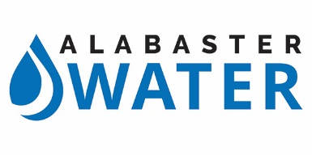
FOR IMMEDIATE RELEASE December 12, 2018

Boil Water Notice Issued for Alabaster Residents
Due to Water Main Break

Alabaster, AL – For the health and safety of our residents, the Alabaster Water Board is issuing a BOIL WATER NOTICE to all Alabaster Water customers for a minimum of 48 hours. This is due to a water main break and loss of water system pressure along Hwy 31 and Hwy 68.
Alabaster Water is working diligently to restore water service as soon as possible to all customers. Residents will be informed when the boil water notice is lifted.
To help ensure water is safe to consume and use, follow these important steps:
1. Bring tap water to a rolling boil
2. Boil for one minute
3. Cool before using.
Until given further notice, Alabaster residents should use boiled or bottled water for drinking, making ice, washing dishes, brushing teeth, and food preparation.
When water mains lose pressure, this increases the chance of untreated water and harmful microbes entering the water causing a health hazard.
Harmful microbes in drinking water can cause diarrhea, cramps, nausea, headaches, or other symptoms. This also poses a special health risk for infants, some elderly, and people with severely compromised immune systems.
If you experience any of these symptoms and they persist, please seek medical advice.
For residents who have questions, please contact Alabaster Water at 205-663-6155.

